Business Plan

Business Plan

Example Business® Pty. Ltd.

"Example Business® will provide the best and simplest ecommerce enabling solution for small-medium businesses in Australia."

Business Plan
(First Name, Surname)
Executive Director
Example Business® Pty. Ltd.
Ph: (xx) xxxx xxxx Fax: (xx) xxxx xxxx
Email: info@cheapwebsites.ws

Table of Contents

Executive Summary | 3-6

Company | 7-8

Management Team | 9

Biographies | 10-14

The Product | 17-20

The Industry and the Market | 21-25

Competition | 26

Strategies and Competitive Edges | 27

Financials | 30

The Example Business® in Action | 37

Funding | 38

Executive Summary
Type of Business

This is a 'virtual' shopping cart that allows businesses to sell products securely via an Internet Website.

Company Summary

With the advent of the Internet, retailing has taken a considerable leap into the 21st century. Boundaries are no longer limited by geographical location. With the Internet's emergence as a retail consumer medium, and its increased profile in day to day life, opportunities exist for businesses to identify and implement completely new methods for the marketing of their products.

Example Business® intends increasingly to tackle the rapidly expanding market of ecommerce enabled Websites with a shopping cart designed to be simple to use and simple to navigate. The sale of ecommerce solutions is a multi-billion one and Example Business® intends to focus on the huge small to medium business market.

The Example Business® team believes the Internet is a new landscape, with a temporary window of opportunity for staking out territory now that won't be available later.

We see huge potential in the focusing and development of our product to the small to medium size business that wishes to obtain a cost effective, easy to use and implement ecommerce solution. Example Business® enables any company anywhere to sell products to any person in the world who has Internet access.

Example Business® has developed, and is continuing to develop, an interface and system that, according to considerable research of site owners and Internet purchasers, has two essential features.

The first is that it is incredibly easy to use. Minimal computer knowledge only is required. A 7 step process completes the entire process of placing a product for sale on the Internet. This takes approximately 45 seconds per product.

The second feature is the easy navigation interface that allows the customers the easiest to use shopping cart available (57% of Internet shoppers abandon the shopping process due to navigation difficulties. Our research indicates that only 3% of shoppers abandon an Example Business® due to these same factors).

Example Business® is being developed through close benchmarking of existing products and the close analysis of consumer behavior when interacting with this new technology. We've identified the best available, identified through research of Internet purchasers what the limitations are, and developed a product to meet the needs.

Product Description

Just as a retailer needs to ensure that products are presented in the best possible light, so do Internet retailers. In presenting products via the Example Business® system, the retailer can provide detailed descriptions as well as photographs and indicate variables related to the product and how those variables affect price. Each Example Business® can be simply modified to incorporate individual colors, styles and presentations into it.

It combines an easy to use interface that enables the newcomer to the Internet to develop an online catalogue and sales system literally within minutes.

The Example Business® allows secure details, such as Credit Card information, to be entered and processed over the Internet to facilitate fully the sale of goods. All user information passing through the system is digitally encrypted and secured by Secure Socket Layers (SSL), providing total security.

ABC Magazine, Australia's most popular software review magazine, described Example Business® thus: "The ease of operation is incredible. Every business should have a Website and every retailing business Website should have an Example Business®."

The Example Business currently retails at $295 pa (licensing fee) with a $60 set up fee (a one off).

Introductory and Market Description

The current ecommerce enabling market is a multi-billion dollar industry.

The adoption of Internet technology by mainstream business is shaping the New Economy. More and more businesses recognize the importance of Web-based sales solutions as integral to continued growth and ongoing success.

Shopping Cart software is an immature industry within Australia characterised by high potential growth rates, low barriers to entry and many opportunities. As the public perception of the safety of credit card transactions over the Internet slowly increases so does the viability of ecommerce enabled Websites.

Research indicates that the longer a user has been using the Internet, the more likely he/she is to purchase. With an estimated 1.4 million Australians accessing the Internet for the first time last year, this market cycle will very quickly impact on the number of businesses requiring ecommerce enabled sites.

Objectives

- To reach sales of $1.4 million in the financial year ending (date).

- To achieve strong branding Australia-wide by (date).

- To be acknowledged as the world’s premier developer of 'virtual' shopping carts by (date).

Competitive Analysis

The competition amongst Internet shopping cart solutions is very fierce. The bulk of the target market wants an easy, cost effective solution that enables them to transact business on the Internet.

At present, there are approximately 30 serious competitors in the market worldwide.

Of these 30 companies, many companies offer a shopping cart with the proviso that the cart component is hosted on their Web server. The purchase occurs through the software of the third party host and the account of the client (whose site is selling the product) is credited minus a sales fee. This fee varies from 3-8% of the sale. Some of these companies also provide the merchant facilities that enable the purchase.
(Company Name) provides one of the most popular 'Business in a box' products. Their product, which has achieved some success since its launch just 3 months ago was described in Computer Magazine as "…an excellent idea but it's let down by its limited design possibilities. Do you really want your business site to look exactly like someone else's?" (date and page reference).

Example Business® avoids this possibility - the cart is separate to the actual Website design and can be easily altered to reflect the colors and branding of the Website business.

In Australia, no real branding success has been achieved by any one product. This is more related to the non-specialization of companies providing shopping cart software.

These competitors have limited appeal when compared to Example Business® predominantly as a result of the difficult navigational aspects and application issues.

Management

(name), Executive Director, brief biography here.

(name), Director of Development, brief biography here.

(name), Finance & Operations Director, brief biography here.

(name), Research & Quality Director, brief biography here.

Funds Requested

$900,000

Use of Proceeds

We envisage utilising the net proceeds of the sale of some company share for the following; $644,000 for research and development, $980,000 for marketing, with the balance for general operating costs, including salary and administrative costs. This is based upon gaining additional funds from the Federal Government's Core Start R&D Grant division of $500,000 and sales of the cart.

Exit Strategy

Since Example Business® will be marketing to a market with enormous international appeal; we envisage that there are two main attractive alternatives.

1. | Public Listing, in which the company will place its common stock for sale and use its proceeds to develop a global strategy for distribution.
2. | Merger or Acquisition, by an existing software development company in which our technology is either licensed or bought.

Company

Company Summary

Example Business® Pty. Ltd. was founded on (date) by the amalgamation of (company) and (company) and the addition to the team of (name) and (name). The Directors of this company have worked extensively together over the past 18 months, including work on Website design and software development projects.

These businesses have been installed in home offices since their inception, however, they envisage moving to rented premises within the next 2 months.

Company Ownership

Example Business® Pty. Ltd. was incorporated in the state of (state), (country) on (date). The Business Number is (number).

Example Business® Pty. Ltd. is XX% owned by (owner company name).

(company) owns XX%, whilst (company) owns XX%.

The members of the Advisory Board, own XX% each/have options to purchase (number) shares at $(price) per share.

The Directors of Example Business® Pty. Ltd. are (name), (name) and (name).

The Directors of (company) are (name), (name), and (name).

(name) (50%) and (name) (50%) own (company).

The Directors of (company) are (name), (name), (name), and (name). The Directors are (name), (name), and (name).

Company Locations and Facilities

The company is located at (street address).

Example Business® Pty. Ltd. is reviewing renting 200 m² for $3,000 per month.

Company Assets

- The brand name Example Business®,

- the trademark of Example Business®,

- the Website www.examplebusiness.com,

- the proprietary software developed,

- intellectual property associated with the development of the Example Business®, and the

- current customer list.

Current Company Situation

Example Business® Pty. Ltd. has product revenues, a current customer list (with repeating income), and an expense history on which financial projections are based.

The company has achieved its milestones thus far in terms of extensively testing the first version of Example Business®, establishing a market presence and putting together the team and company structure. Market penetration has also been achieved ahead of expectations.

The team is now looking to expand quickly and achieve significant market penetration.

Management Team
Management Philosophy

We believe we have the foundation of a great business.

We have a technically superb product that will help a large number of businesses.

We have a tremendous base on which to build a team capable of realizing the vision. We are constantly reviewing the recruiting of talented people and will be accessing these talents when appropriate. We don't actually think we will ever complete the team. The team needs to be growing all the time, in terms of expertise, skill and experience, to cope with the rapidly emerging technologies of the market.

We have the experience, drive, commitment and passion. We recognize our limitations and have been very proactive in addressing these.

Our position is one of absolute integrity and honesty. We aim to achieve the full potential of the business not through denigrating the competitor products, but by demonstrating the value and excellence of our own products.

We are an experienced, talented and committed team with an excellent product that addresses a large and rapidly expanding growing market.

Management Team

(Name) Executive Director

Pic
"It's all about the team at Example Business®. We recognize that a team with experience, passion, drive and commitment will move the company forward. We believe we have that team."

(Name), Executive Director

Biography

(Name) Executive Director

Pic
"We don't focus just on what looks nice. We focus on what works. The Easy Cart® looks great and works even better."

(Name), Director of Development
Biography

(Name) research and Quality Director

Pic
"Our reviews don't really assess what the Development Team likes. Focus groups are King and Queen …they impact the most on product development."

(Name), Research & Quality Director

Biography

(Name) Finance and Operations Director

Pic
"The distribution channels the company has utilized so far have proven very efficient and cost-effective."

(Name), Finance Director

Biography

Each of the Directors has contributed substantially to the company in the form of "sweat equity." The team believes that it is addressing a market destined to grow substantially in the near future. The team is very confident that both market share and revenue projections will, at a minimum, be achieved in the projected timeframe.

Advisory Board

Pic
"Experience is a great teacher. Having trod the hard road to success, our Advisory Board provides the expertise to round out the team."

(Name), Executive Director

Example Business® Pty. Ltd. has an Advisory Board consisting of shareholders/option holders in the company.

From a diverse background, the Board provides multiple skills that will aid the ongoing achievement of the goals set by the team.

(The members and background of the Advisory Board here).

Management Team Gaps

Sales experience is a weakness.

Legal experience of the team needs bolstering.

General management experience to take the company public.

What to do About Gaps in the Team?

The Example Business® Pty. Ltd. team is very aware of the benefits of benchmarking all areas of the company against industry leaders. The Example Business® has been benchmarked against everything currently available and improved to be the product it is.

Benchmarking the skills of the team is no exception. We certainly recognize our deficiencies and have taken several steps to remedy them. These steps include:

- Identifying and contracting appropriate legal experts to assist in those areas.

- Identifying appropriate sales professionals to employ.

- Identifying and recruiting the appropriate skills required to meet the strategic vision of the company.

- Further developing the Advisory Board to include people with those skills required by the team now and in the future.

We certainly anticipate that the current team will continue to identify talented people that can be recruited. We view the team as a living, breathing entity that needs to grow and develop to meet the rapidly changing technological advancements of the industry.

Management Summary

We are a small company owned and operated chiefly by the four Directors.

The Example Business® team is an experienced, talented and committed team with an excellent product that addresses a large and rapidly expanding market. We are focusing on building a company that provides technical excellence, a company that gives great value to its customers, a company that will be an industry leader.

We anticipate the team growing as we grow, to meet the challenges ahead.

Personnel Plan

We have a very dynamic and cutting edge work environment with a very committed team.

We do expect to be able to increase personnel significantly as sales increase.

We recognise the need for highly motivated and talented team members and will always be identifying appropriate people for future reference.

The management of Example Business® Pty. Ltd. envisages offering a mechanism whereby employees can acquire share options that can become more valuable as the company grows.

Staffing levels have been carefully assessed and projected on the basis that the company needs rapidly to develop products to aid market perception of the company as technologically advanced and innovative. To this end, the bulk of personnel are in Research and Development.

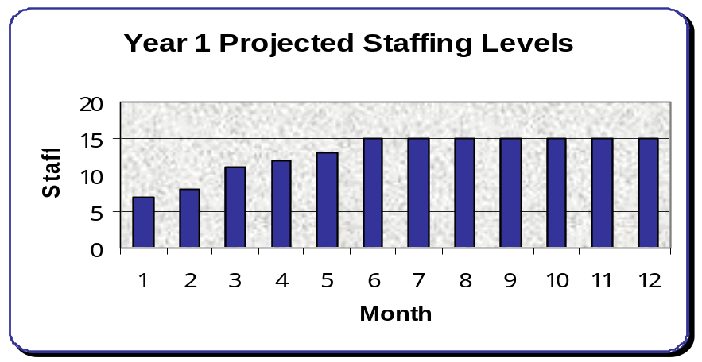

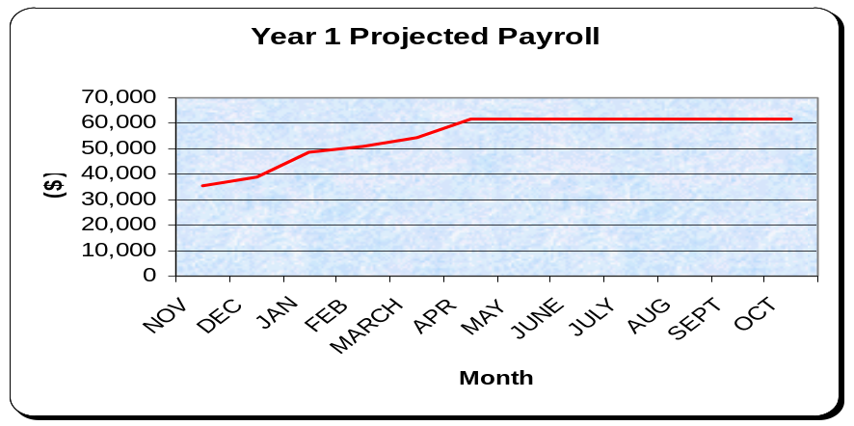

The Product
Example Business® Pty. Ltd. develops and provides stand alone shopping cart system solutions for Websites requiring ecommerce capability. Example Business® Pty. Ltd. makes ecommerce available to the entire market - from the home business operation to large multi-nationals.

Product

Our product is an Internet based shopping cart system. The cart enables the smallest to the largest business to ecommerce enable a Website. Ease of use of the product, as well as its perceived competitive edges, are its biggest unique selling points.

The rapid acceptance of the Internet has been a global phenomenon. The acceptance of Internet shopping has been the most exciting innovation in retailing in 50 years. Worldwide Internet stores had sales of US$900 million in 1996, US$4 billion in 1997, US$8 billion in 1998, with predictions of $108 billion by 2003.

Providing secure commerce functionality, coupled with interactivity and multimedia capabilities, is an integral requirement for sites looking to capitalize on this ever-expanding market. Example Business® provides this capability.

Extensive testing of the software has established that it works across all computer server platforms, indicating that the product is compatible with major systems used by Internet Service providers.

We have found our clients don't buy the software for the product itself. They buy for the benefit of a simple, easy-to-use system that allows them full control of their Website sales system. The client doesn't want the software - he/she wants the benefits of accessing the vastly increased market potential that it provides.

Product features that provide these benefits include:

- Online shopping basket with built in shipping, tax and discount calculations.
- Currency Conversion takes place within the system.
- Customers can save a "wish list", or a list of bookmarks to selected products.
- Upload up to 2 pictures for each product.
- Add variety fields such as size, type and/or color to each product.
- Add add-on sales functionality to the cart. For example, the customers might buy a plant ball. At time of checkout, they are asked if they would also like to purchase some fertilizer that is used on that particular plant.
- Full customer management facilities, including the ability to mass mail customers (with mail merge capabilities), and place customers in groups to be used for discount purposes.
- Select the payment methods that you will accept (e.g. Visa, MasterCard).
- Select the shipping methods that you will use, and create shipping tables for each of those methods.
- Create discount rules for customers in particular geographical areas, customers in particular groups, or on particular categories of products.
- GST ready - create your own tax rules.
- Create reports about your most popular products, where the income is coming from, and sales summaries.
- Create reports about the most viewed products, the searches customers are making, and the URL's that customers are coming from.
- The ability to perform transactions securely over the Internet.

Software development clearly poses the most formidable obstacle to Example Business® Pty. Ltd. moving successfully into the market as a major player. To mitigate this exposure, the development process has been divided into 5 segments (form, merchant user interface, customer interface, input and output) for simultaneous development. Each segment will be the responsibility of a specific software developer, with the Director of Development ensuring overall co-ordination of the development. He, in turn, will closely liaise with the Director of Research, with both Directors reporting to the Executive Director.

The aggressive development plan will require the addition of skilled software engineers to accomplish the stated tasks. Four candidates have been identified and interviewed by the Director of Development. The response for committing to the company upon funding has been very encouraging.

Year 1 Projected Development Cycle
Month

 | 1 | 2 | 3 | 4 | 5 | 6 | 7 | 8 | 9 | 10 | 11 | 12
Example Business® Version 1.0
Software testing
Focus Group tests
Launch
Target Group research
Example Business® Version 1.01 designed
Testing commences
Version 1.01 specifications
Focus Group research
Software testing
Focus Group tests
Beta testing
Launch
Target Group research
Example Business® Version 1.02 designed
Testing commences
Version 1.02 specifications
Focus Group tests
Beta testing
Launch
Target Group research
Example Business® Version 1.03 designed
Testing commences
Version 1.03 specifications
Focus Group tests
Beta testing
Launch

Market Penetration

The company (through the incarnations of (company name) and (company name) has been successful in penetrating the local market with the cart system. There are currently 22 Websites utilizing the Shopping Cart. Each license fee is $(price) pa. Our previous distribution channel has been solely Websites designed by the businesses. We have since expanded to commence selling to local Web development firms.

Current clients/users include (Name), (Name) and (Name).

Product Description

Just as a retailer needs to ensure that products are presented in the best possible light, so do Internet retailers. In presenting products via an Example Business®, the retailer can provide detailed descriptions, photographs and indicate variables related to the product and how those variables affect price.

The Example Business is a software development that enables very clear and precise photographic and copy descriptions of items for sale. Each Example Business can be simply modified to incorporate individual colors, styles and presentations into it.

The Example Business® allows secure details, such as Credit Card information, to be entered and processed over the Internet to facilitate fully the sale of goods.

The Example Business® can be set to calculate automatically and display discounts to loyalty club members, keep track of purchases and calculate shipping charges to be applied.

It combines an easy to use interface that enables the newcomer to the Internet to develop an online catalogue and sales system within minutes.

All user information passing through the system is digitally encrypted and secured by Secure Socket Layers (SSL).

ABC Magazine, Australia's most popular software review magazine described it thus: "The ease of operation is incredible. Every business should have a Website and every retailing business Website should have an Example Business®."

The Example Business currently retails at $(price) pa (licensing fee) with a $(price) set-up fee (a one off).

Our research of the small to medium size business market indicates a 78% acceptance of the product at the current prices. When compared to the competitor products this figure increased to 92%. The group selected for interviewing represented a broad range of skill levels in terms of Internet expertise.

Product Warranty

Example Business® Pty. Ltd.'s standard warranty will be for the life of the cart system. Free upgrades for life, along with Technical Support, are also offered for the version the customer purchased. This is the industry standard.

To encourage purchase, a free 30-day trial is offered for carts downloaded from the Internet. These carts have special code written into them that disables the cart after 30-days if the product has not been purchased. Our research indicates a 55% update rate with this "Try before you buy" method.

Future Products

Since the company's strategy will be one of positioning Example Business® Pty. Ltd. as a technologically advanced and innovative firm, future product development is a key concern of management. Substantial resources are allocated for Research and Development.

Future products of Example Business® will be related to providing Web based sales systems for Websites.

The ongoing development of Example Business® will involve developing statistical information related to buyer habits (products viewed, time spent reviewing each product, exit areas, average sales price, etc). These enhanced versions and subsequent upgrades of the cart will aid the ongoing licensing sales.

Security products and online sales information will also be the focus of ongoing research and product development by Example Business.

Audio and video capabilities will be incorporated into the Example Business® to facilitate the ability to provide the most extensive and effective ways to demonstrate products online.

A virtual central shopping centre will also be built that will 'house' all clients with a shopping cart. What this means for clients is a value added service that will generate additional traffic to their site via this central base. The base will be a linking point/portal for Example Business® and shoppers in general.

Example Business® Pty. Ltd. intends to develop a full line of shopping cart systems to meet the market needs. To that end, designing of the company's second cart system is underway with preliminary review nearing completion.

The end result of the development of shopping cart systems is to provide a full range of carts, with one suitable for every situation - from single item carts to database driven carts capable of selling up to one million items.

The Industry and the Market

Positioning Statement

For businesses looking to expand their distribution channels and catchment area Example Business® offers an easy software solution. Example Business® allows a business of virtually any size access to the tools necessary to access the sales market potential of the Internet.

Market Growth

The growth of business Websites in Australia has been growing at a rate of 42% pa during the last three years, according to the ABS. It is a little more difficult to gauge the growth of ecommerce enabled Websites. With the increasing sophistication of Web users, the market potential of an ecommerce enabled Website it is becoming more and more obvious to business people. It’s clear that Internet technology will greatly increase both competition and market potential.

Industry Analysis

The adoption of Internet technology by mainstream business is shaping the New Economy. More and more businesses recognize the importance of Web-based sales solutions as integral to continued growth and ongoing success.

Industry Participants

Shopping Cart software is an immature industry within Australia characterized by high potential growth rates, low barriers to entry and many opportunities. As the public perception of the safety of credit card transactions over the Internet slowly increases, so does the viability of ecommerce enabled Websites.

Research indicates that the longer a user has been using the Internet, the more likely he/she is to purchase. With an estimated 1.4 million Australians accessing the Internet for the first time last year, this market cycle will very quickly impact on the number of businesses requiring ecommerce enabled sites.

Market Analysis Summary

The target market for Example Business® Pty. Ltd. is the small-medium business looking to access the sales and distribution channel that the Internet provides.

With over 1.1 million businesses in Australia alone*, and an estimated 50% of those falling within our target market, Example Business® Pty. Ltd. calculate that the shopping cart is a potential $162 million industry. This figure is a recurring one taking into account the per annum licensing fee required.

Between 1983-84 and 1998-99 the number of small businesses increased by 71.4%, which is equivalent to an increase of 3.7% per annum:

- Small employing businesses increased by 87.5%, or 4.3% per annum.
- Non-employing businesses increased by 55.0%, or 3.0% per annum.

With the rapidly growing international market also available, it can be seen that market potential is enormous.

According to the Australian Bureau of Statistics (ABS), 38% of Australian businesses grossing over $41 million in sales have a Website. Of these, just 8% are ecommerce enabled. This has to do with technology restraints, resource constraints and product suitability for Web based sale.

The market beyond the Australian shores includes tens of millions of businesses.

Taking Australia as the base market, the IDC forecasts a huge increase in ecommerce.

Ecommerce forecasts for Australia | 1998 | 2001
Users buying goods and services over the Web | 419,132 | 1,641,066
Year-end commerce revenue (in US millions) | $265.093 | $5078.644
Source IDC, Market Forecast for Internet Commerce, 1996-2001 (October 1997).

The team believes the Internet is a new landscape, with a temporary window of opportunity for staking out territory now that won't be available later. A very significant investment needs to be made in the marketing of the business to establish the ground from which we can grow.

* 1321.0 Small Business in Australia, ABS, 1999

The Market

There is overwhelming evidence of the Australian market adopting and following business and social trends established in the USA. For this reason, we project very substantial growth opportunities in ecommerce (652,000 Australians used the Internet to purchase or order goods or services for their own private use in the 12 months to August 1999—an increase of 227,000 in 12 months) and for software such as Example Business®.

Ecommerce growth projections.

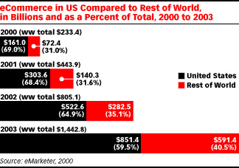

Market Segmentation

The target customers are businesses requiring an Internet based sales avenue. Our target customers don't have the resources and skills currently required for setting up and maintaining Websites, so the integration of an Example Business® into the system will be very easily achieved. In the event that our clients lack the very simple technical skills to load products into the cart, the option will be available for Example Business staff to maintain the cart's product range for them.

We will access the clients required via a variety of methods. Direct approaches to Internet Service Providers, strategic alliances with Web development firms and technology groups will be made to increase market penetration initially.

Focusing on the fast growing small and home office markets will also be a priority of the team. Being less sophisticated computer users means that this group will be anxious to find a simple, easy to use solution to enable Web-based transactions.

Approaches to large retailers will also be made, as these constitute a very important segment, not only in size but also in gaining credibility to aid the positioning to the general market.

Large scale branding advertising (and a highly targeted PR campaign) of the product is essential to achieve significant market penetration. We see this as being easily achieved within Australia, given the financial resources.

Market Trends

The most important trend that affects Example Business® Pty. Ltd. is the increasing Internet uptake by Australians. According to the ABS, "An estimated 6.4 million adults accessed the Internet at some time over the 12 months to May 2000, which was 54% of Australia's total adult population. In comparison, nearly 5.6 million adults accessed the Internet at some time over the 12 months to August 1998, which was 41% of Australia's adult population."

According to the ABS, in the 12 months to May 1999, 38% of Internet purchases by Australians were software products.
With an increasing market base, more and more businesses will utilize the Internet as a sales avenue. Example Business® Pty. Ltd. aims to capitalize on this growth.

Internet Growth in Australia since 1996
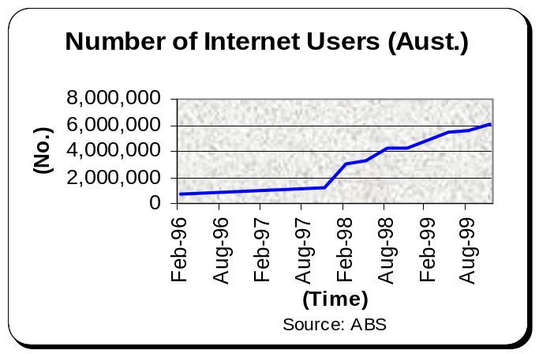

Market Needs

As competitive pressures increase from both domestic and international sources, business managers are being forced to review closely distribution channels and potential new markets.

The only need that the target market has is something that not only allows the sale of products via the business Website, but a system that actively aids the sales process.

According to ABC, almost 60% of sale shopping carts are abandoned before the sale is complete because of the difficulty navigating through to the end of the sale.

The simplicity of using the Example Business® from the buyer's perspective is one of the major advantages of the Example Business®. Our extensive testing indicates that the Example Business® has very significant usability advantages over competing products.

The need of the market is a system that is simple to set up, and that facilitates and assists (through ease of navigation) Web-based sales. Example Business® meets that need better than anything else on the market.

IT has become so central to business strategy that more and more managers must have an understanding of basic technology trends to do a competent job.

Marketing Strategy

The Example Business® name will be strongly marketed within the first six (6) months in an effort to establish brand awareness for the product.

Our marketing strategy will be related to ensuring a very strong focus on reaching the target market directly. Identifying choice influences of the target market is central to the research effort. Example Business® Pty. Ltd.'s team firmly believes that providing quality products is its first and foremost task in achieving targeted market share. Innovation and service are essential components of quality; substantial attention will be focused in these areas.

Seminars focused on Internet education will be held regularly.

We will use a heavy PR component because of the critical need for public marketplace review. The team has strong credentials and contacts in this area, achieving considerable success for others in this area previously.

The relatively new uptake of Internet technology means that clear lines of distribution and developed relationships are not greatly advanced. We aim to take advantage of this through encouraging word-of-mouth recommendation and branding.

With strong research, we aim to establish ourselves as an industry leader and expert in ecommerce issues.
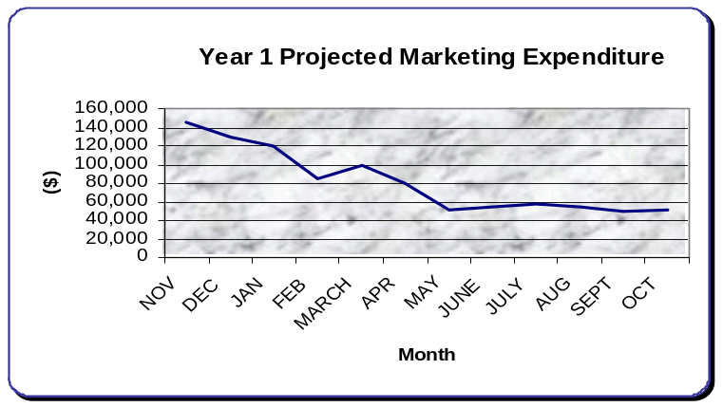

Technology

The cutting edge nature of our product means that competitors will be quick to develop a cart similar to the Example Business®. Trademark and licensing agreements will be enforced to protect the property of Example Business® Pty. Ltd..

We recognize the dangers of competitors gaining benefit from our advancement but feel that our focus needs to be on establishing the company as a technologically advanced one. With an excellent product well-branded we envisage a strong competitive edge.

Competition
Competitive Comparison

The competition amongst Internet shopping cart solutions is very fierce.

At present, there are approximately 30 serious competitors in the market worldwide.

Of these 30 companies, many companies offer a shopping cart with the proviso that the cart component is hosted on their Web server. The purchase occurs through the software of the third party host and the account of the client (whose site is selling the product) is credited minus a sales fee. This fee varies from 3-8% of the sale. Some of these companies also provide the merchant facilities that enable the purchase.

The following is Example Business® Pty. Ltd.'s analysis of main competitor product strengths and weaknesses.

Competitor | Overview | Pros | Cons
 | American firm with a variety of similar carts. | Established within the marketplace. | Upgrades are expensive. Installation is difficult for non-computer workers.  Poor graphical look.
 | American company with good market penetration. | Easy to set up.  Good reputation. | Limit themes - all carts look similar.
 | Struggling company, largest virtual shopping mall in the world. | Strong name awareness. | Negative publicity recently regarding financial position.
 | Sausage Software latest product. | Well capitalized with strong strategic alliances. Marketing has been extensive. | All sites look similar. Difficult to set up. Buying this means you are committed to a Website look, hosts, etc.
 | Small Australian company who developed own software. | Relatively expensive ($4,000+).  Undercapitalized company. | Need computer programmer to utilize.

In Australia, no real branding success has been achieved by any one product. This seems to be related to the non-specialization of companies providing shopping cart software.

Competition and Buying Patterns

Market share generates market share in the software business. Branding and recommendations are also a tremendous source of generating market share.

The choice influences in software purchases are related predominantly to fear. Our research indicates a high degree of relevance is given to ensuring that the 'right' choice is made. With a significant price advantage, we view the Example Business® as having a significant edge over the competition.

Buyers want brand names. Brand names provide security. The quality of one software product over another is very difficult to measure for the consumer and the brand name provides some assurance. Strong branding is achievable only in mainstream product lines, but there is plenty of scope for smaller products to achieve buyer confidence for specialist solutions.

Strategies and Competitive Edges
Our main strategy at Example Business® Pty. Ltd. is to establish Example Business® at the top of the quality scale, featuring the combination of ease of use, simple visitor navigation and cost effectiveness for the buyer who requires a premier ecommerce enabling solution. Tactics associated with the development include significant ongoing research and an absolute commitment to innovative product development.

Competitive Edge

The main area critical to the successful implementation of any ecommerce enabled Website is functionality. 57% of online buyers abandon the sales process due to navigational difficulties.

Our competitive edge is the simple owner-operator capability of the software. This greatly reduces cost and the commitment of resources for the client. Also, our strong research division and our already demonstrated commitment to long term client satisfaction provide another competitive edge.

Competitive features include:

- Simplicity - manifested in ease of use for both the buyer and seller.

- Performance Capability - custom-made carts for 1 to a million products.

- Flexibility - can be adapted for a wide range of products and can be adapted for a wide range of uses besides ecommerce.

- Price/Performance - very price competitive for state-of-the-art software.

Pricing Strategy

The pricing strategy for Example Business® has been determined after extensive competitor market analysis and target market research. The licensing fee of $295 pa appears reasonable to the retail target market. Potential price hesitancy on the part of customers will be met head on with specification sheets comparing Example Business® product performance with competitors' and on-site product demonstrations.

Wholesale discounting (25%) is offered to industry players, such as Web developers to encourage the use of the Example Business®.

Promotion Strategy

A particular strength of the team is marketing, PR and Internet marketing. Substantial efforts and resources will be made in the start up phase of Example Business® Pty. Ltd. to aid branding.

Widespread media advertising will be used to develop the branding of the Example Business®.

Distribution Strategy

Aside from the Distribution Channels mentioned previously the team aims to obtain shelf space in retail outlets for the Example Business®. A packaging and retailing expert has been used to consult on this aspect of the distribution chain.

Sales Strategy

Example Business® Pty. Ltd. will only use in-house salespeople with impeccable credentials and extensive product training. Emphasis will be continuously focused on the needs of the customer.

During the initial stages, both the Executive Director and the Director of Development will play key roles in establishing contact with target customers.

Sales personnel will be compensated with a relatively standard base salary with performance incentives payable quarterly. Sales personnel are expected to turn in weekly reports, outlining initial contacts, follow ups, and projected sales.

Professionalism in both appearance and approach will be the guiding principle for Example Business® Pty. Ltd.'s sales force. Thorough knowledge of customer needs, products and competitor products will be reinforced with regular training and monthly meetings conducted with the management team.

We will continue to work towards developing a Website to enable transactions of our sales through downloading of the site over the Internet. Additionally, we will offer direct mail receipt of the Example Business®. Ongoing review is being made to assist the development of strategies to aid retail store sales of the product.

Sales Forecast

The sales forecast for 2000-2001 depends on selling 4,170 Example Business's®.

We anticipate a slow start to sales, which will quickly increase with word-of-mouth, brand awareness and advertising influences.

Strategic Alliances

We view strategic alliances as central to the future success of Example Business®.

Alliances with Web development companies, Web Hosting companies, Internet security firms, 'real time' transaction specialists, industry and government bodies and retailers are very important to assist in the establishment of a viable business.

Agreement has been reached with (ISP) to provide the necessary hardware and software required for secure hosting of sites.

(Name) (Real Time Transaction specialists) have been approached with positive initial response.

Strategy and Implementation Summary

Our strategy is based upon exposing the Example Business® to the target market directly. Branding exercises will be utilized to the very specific niche markets we will be trying to penetrate.

Our marketing infrastructure is developed enough to achieve large geographic reach. Whilst our technology is cutting edge and technologically sophisticated, the ease of use ensures that it can be effectively utilized by the large numbers that make up the potential market.

Distribution Channels

The Example Business® is well suited to a variety of distribution models.

Example Business Pty. Ltd. currently employs the following distribution methods.

- Downloadable from the company Website.

- Available on a CDROM.

- Uploaded to a Web Host server directly from Example Business® Pty. Ltd..

All of the distribution methods are cost efficient and, in the case of downloading, automated completely.

There is a $60 set-up fee associated with all Example Business® design and install sales, as well as the $295 pa licensing fee.

Keys to Success

The keys to success for Example Business® Pty. Ltd. are related to the cart quality, ease of use and perception of competitive advantages. These include:

- The right management team, with strong foundations in marketing, management, finance and product development.

- Ensuring ease of access to the cart. This includes promotion, ease of downloading the software and ease of use.

- Uncompromising commitment to the quality and usability of the cart.

- Obtaining a perception of a competitive advantage in the minds of the target market.

- Enough working capital to support ongoing research and product development.

- Provide for the satisfaction of 100% of our customers. Our customers are very valuable to us, and we will design a customer care plan to manage complaints, implement customer feedback, and predict future conflicts.

Financials
Important Assumptions

The financial plan relies on important assumptions related to the operations of Example Business®.

- We assume a slow growth economy with no major recession.

- We assume a growth rate of 12% in our market.

- We assume there will be no technology changes within 2 years that will make the business obsolete.

- We assume access to the funds required to maintain financial projections as outlined.

- The Internet infrastructure will be maintained.

- Key personnel remain with the company for at least 2 years. Service contracts will be used to aid this.

- Depreciation is calculated on all fixed and capital assets assuming 5-year lives and straight-line computation.

- Interest is earned at 3% pa.

- Accounts Payable at 5 days.

Government Funding

As a research-based company that is developing new technology, the Example Business® Pty. Ltd. team anticipates access to Government funding. The Federal Government R & D Core Start grants are one avenue that appears to have criteria favorable to Example Business® Pty. Ltd.. An initial discussion with personnel from this body has indicated strong likelihood of Example Business® Pty. Ltd. meeting key eligibility criteria.

The Core Start R & D grants are provided to eligible companies. Eligibility criteria are: "The project must essentially involve research and development, and can also include related product development and related market research activities." Eligible companies can apply for a grant of up to 50% of eligible project costs.

Key Performance Indicators

Key performance indicators are sales, operating expenses, gross margins, repeat clients and growth of the value of the business.

Projected Cashflows

Sales By Units

Product Details and Assumptions

Projected Balance Sheets

Projected Business Ratios

Projected Personnel Plans

Funding
Funding Requested

Ideally, we want to bring $900,000 of equity investment from investors compatible with our plan and vision in return for some equity ownership.

We seek investors who have a fundamental respect for providing our clients with value and who are interested in building a business and a future for Example Business® Pty. Ltd.. The focus is certainly on making a return on investment, but it is also about bringing to fruition the vision for the company to become recognized as a world leader in the ability to easily ecommerce enable Websites.

We seek investors who have a fundamental respect for realistic forecasts and conservative cashflows.

We seek investors compatible with our growth plan, vision and management style.

A point to note here is that at this stage, the management of Example Business Pty. Ltd. envisages offering a mechanism whereby employees can acquire share options that can become more valuable as the company grows. We view the team at Example Business® Pty. Ltd. as integral to success and know that a well rewarded and 'ownership' situation will greatly enhance performance.

We recognize the importance of remaining flexible in our negotiations, so will refrain from discussing specifics here so as not to undermine the ability of both sides to present an appropriate investment structure.

Example Business® Pty. Ltd. doesn't just want an investor. We want a team member who is fully committed to the success of the company; who provides very valuable input into the company's developing strategic direction; who has the experience and relationships that can assist in the identification and accessing of the resources required for the building of the business.

